ECE558 Homework 05 (100 points in total)

*How to submit your solutions*: put your report (word or pdf) and results images (.png) if had in a folder named [your_unityid]_hw05 (e.g., twu19_hw05), and then compress it as a zip file (e.g., twu19_hw05.zip). Submit the zip file through **moodle**.

*If you miss the deadline and still have unused late days (we changed it to 0.5-day based metric, please check your email for the notice), please send your zip file to TAs and me.*

**Important Note**: We will **NOT** accept any replacement of submission after deadline, even if you can show the time stamp of the replacement is earlier than the deadline. So, **please double-check if you submit correct files**.

# You can still use your late days if had and needed.

**Problem 1**. (16 points). Please select T/F (True or False) for the following statements.

* [ False ] if available hardware, or software routines, have only the capability to perform the DFT, we can use it to compute the inverse DFT using 𝑓[𝑥] =

1 -𝐷𝐹𝑇-{𝐹[-𝜇]-}.

𝑀

* [ True ] In either domain, time or frequency, the function is not periodic then the argument in the other domain runs continuously. If in either domain, time or frequency, the function has a discrete argument, then the transformed function in the other domain is periodic.
* [ False ] Fourier spectrum carry much of the information about where discernable objects are located in an image.
* [ True ] To construct a Gaussian image pyramid for a given image, we first down- sample it using bilinear interpolation method, and then apply a Gaussian filter to smooth potential artifacts introduced by the down-sampling.
* [ False ] To handle wraparound error in filtering in frequency domain, we need to pad a given input image before filtering. Either centered padding or left-top-based padding works.
* [ True ] Image restoration is usually posed as an objective process which utilizes a criterion of goodness that will yield an optimal estimate of the desired result.
* [ False ] An edge can be caused by depth discontinuity or surface color discontinuity. Corner locations are co-variant w.r.t. translation, rotation and scaling.
* [ False ] For the Canny edge detector, we will obtain more and stronger edges if we use larger Gaussian kernel size.

**Problem 2.** (10 points).

* 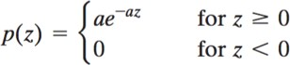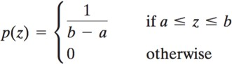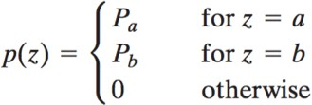Select the noise type from (a)~ (f) which describe the noise best in each figures: (a) , (b) 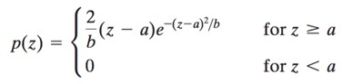, (c) 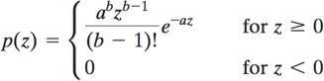

(d) , (e) , (f)

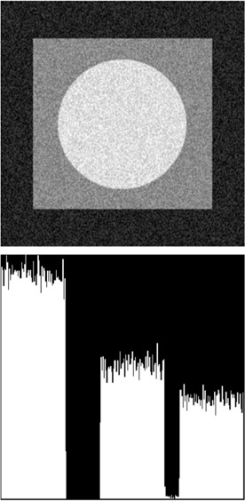

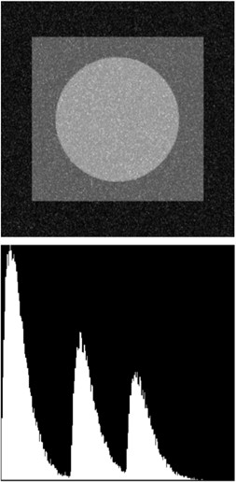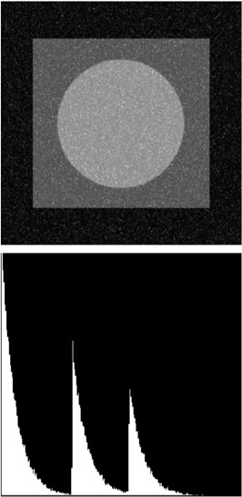

Uniform Noise(e) Exponential Noise(d) Erlanga Noise (c)

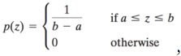 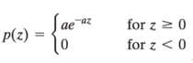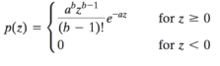

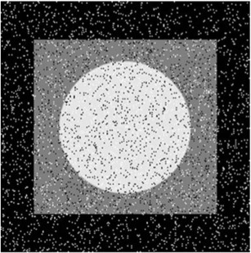

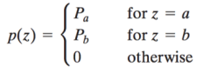

Salt and pepper noise (f)

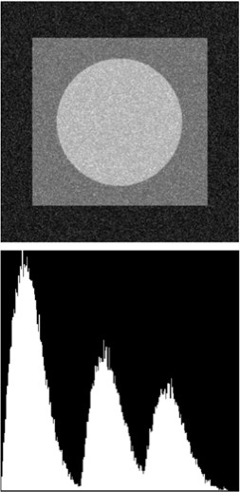

Rayleigh noise (b)

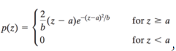

* 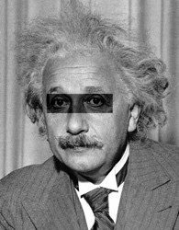To find 𝑔[𝑥, 𝑦]  in a given image 𝑓[𝑥, 𝑦] or , select the best method from (a)~(d) which generate the result images ℎ[𝑥, 𝑦]. Let 𝑔̅ be the mean value of 𝑔[𝑥, 𝑦].

*h*[*m*,*n*]  *g*[*k*,*l*] *f* [*m*  *k*,*n*  *l*]

(a)

*k* ,*l*

, (b)

ℎ[𝑚, 𝑛] = ,{𝑔[𝑘, 𝑙] − 𝑔̅}𝑓[𝑚 + 𝑘, 𝑛 + 𝑙]

𝑘,𝑙

(*g*[*k*,*l*]  *g* )( *f* [*m*  *k*, *n*  *l*]  *fm*,*n* )

*h*[*m*, *n*]  *k*,*l*

 0.5

*h*[*m*,*n*]  (*g*[*k*,*l*]  *f* [*m*  *k*,*n*  *l*])2

*m*,*n*

(*g*[*k*,*l*]  *g* )2 ( *f* [*m*  *k*, *n*  *l*]  *f* )2 

(c)

*k* ,*l*

, (d)

 *k* ,*l*

*k* ,*l* 

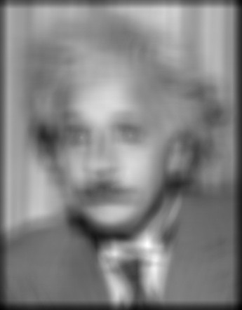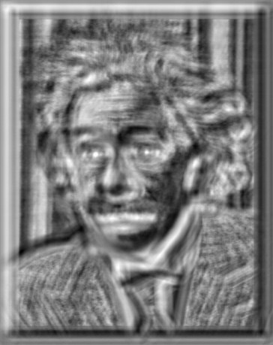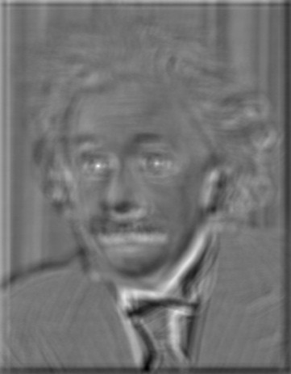

The result of [(a)] The result of [ (d)] The result of [(b)]

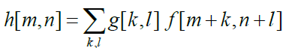 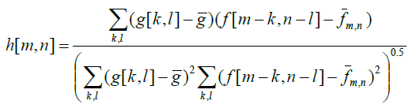 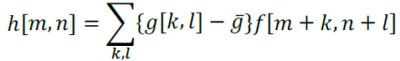

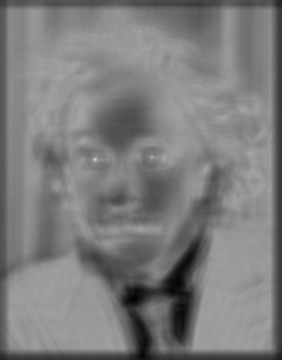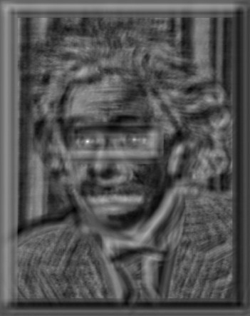

The result of [(c)] The result of [(d)]

 

**Problem 3.** (12 Points)

* Write the operation name (e.g., “x-derivative of Gaussian”) for each of the steps of the Canny edge detector (b) to (g)

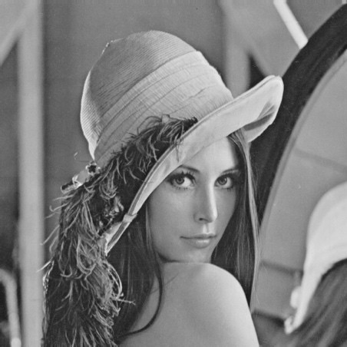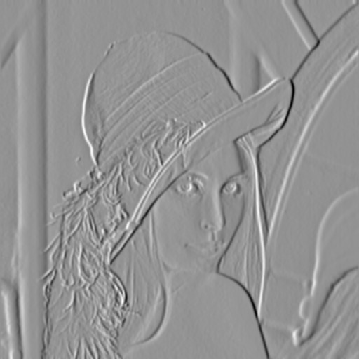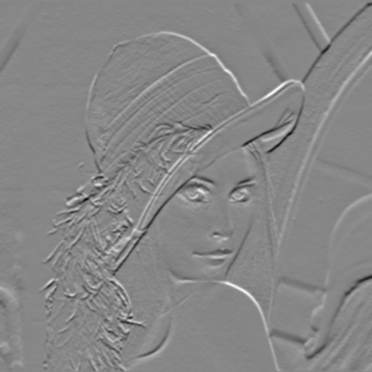

* 1. [input image]
  2. [ X Derivative of Gaussian ]
  3. [ Y Derivative of Gaussian ]

Gradient Magnitude ]

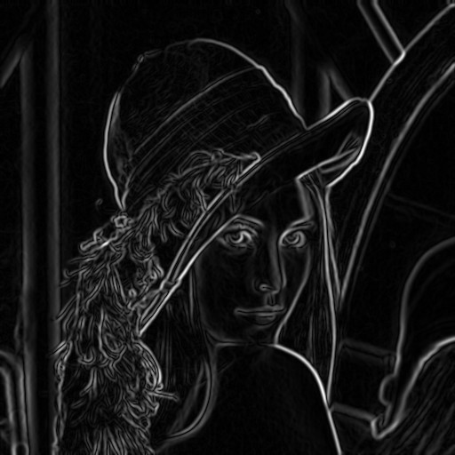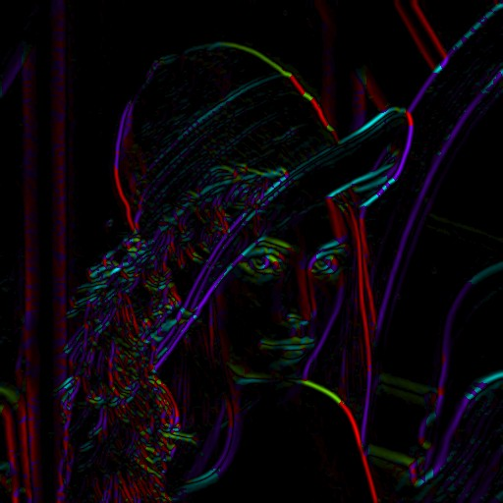

d)

[

e)

[ Theta = atan2(gy,gx) ]

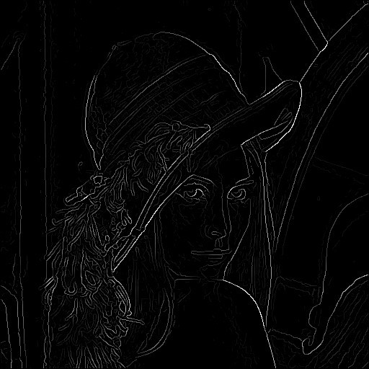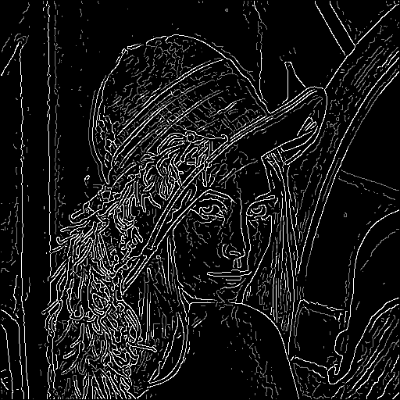

1. [ After Non-Max Suppression ]
2. [ Hysteresis Thresholding ]
3. 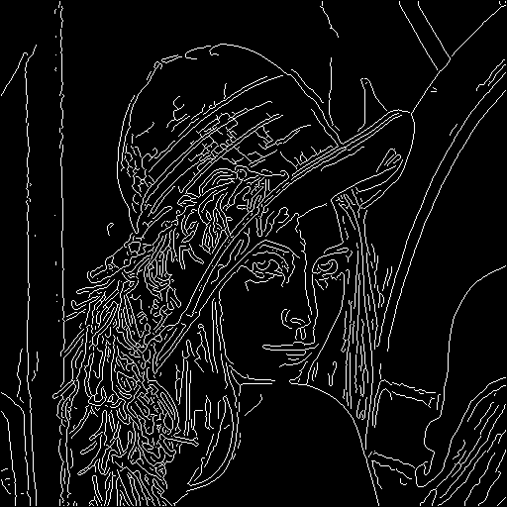[ Final Canny Edges ]

**Problem 4**. (12 points). Consider a linear, position-invariant image degradation system with impulse response

ℎ(𝑥 − 𝛼, 𝑦 − 𝛽) = 𝑒#[(𝑥#𝛼)2)(𝑦#𝛽)2]

Suppose that the input to the system is an image consisting of a line of infinitesimal width located at 𝑥 = 𝑎, and modeled by 𝑓(𝑥, 𝑦) = 𝛿(𝑥 − 𝑎), where 𝛿 is an impulse.

Assuming no noise, what is the output image 𝑔(𝑥, 𝑦)?

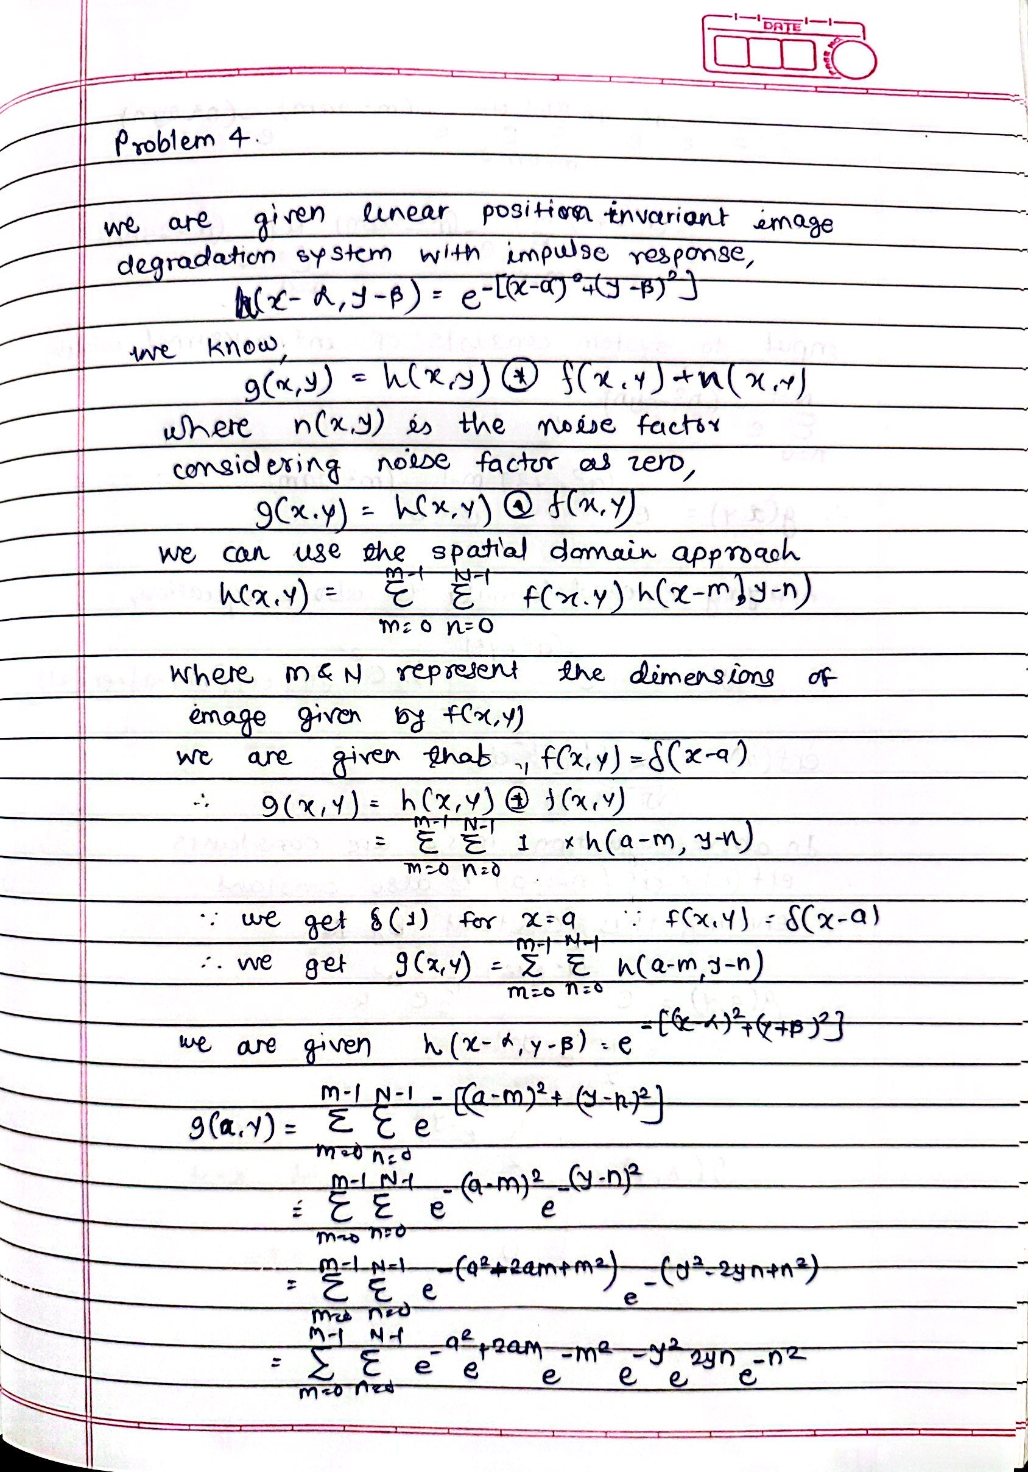

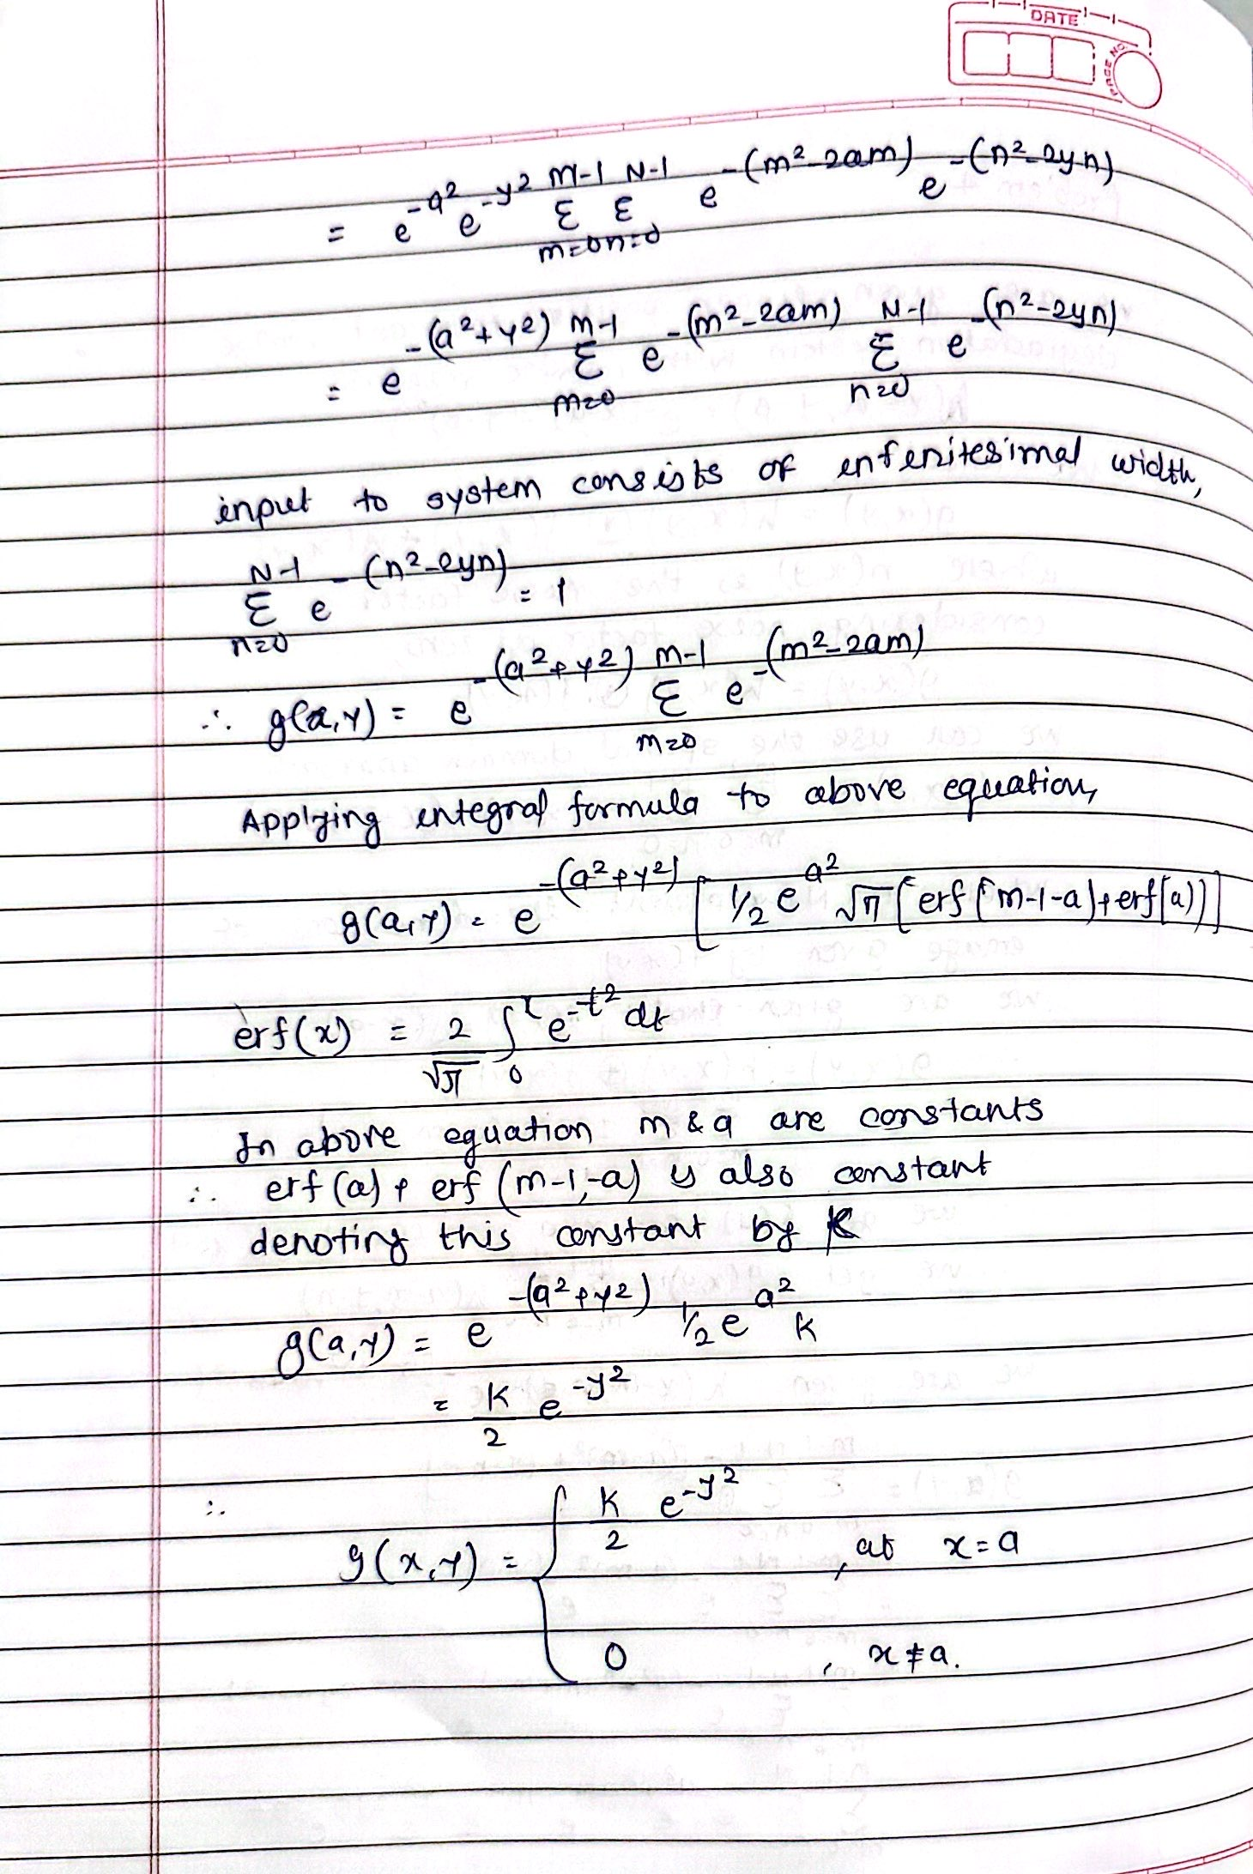

**Problem 5**. (20 points).

* Show the basic idea of detecting corners using the given toy image. Ans.

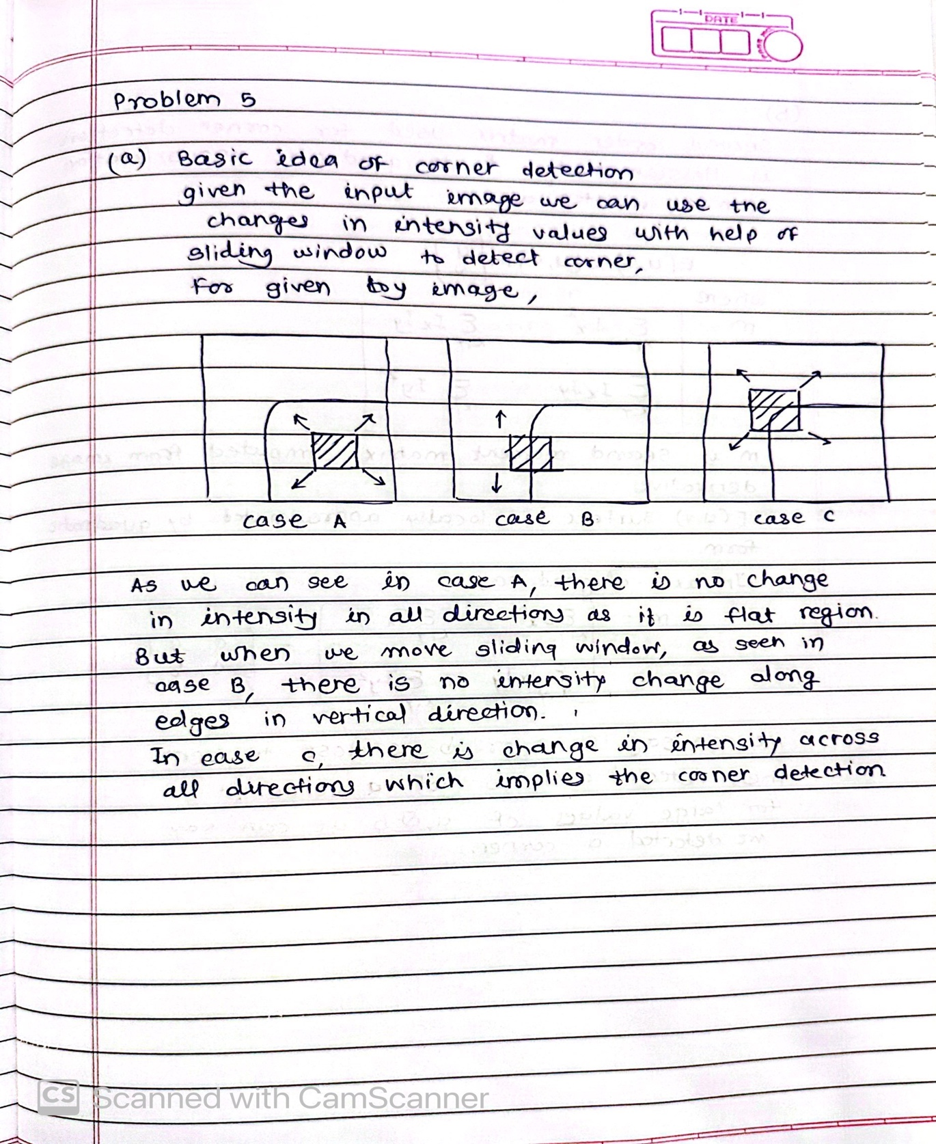

* Show why the second moment matrix is important in detecting corners using detailed derivation. Define your nations and explain steps in the derivation.

Ans.

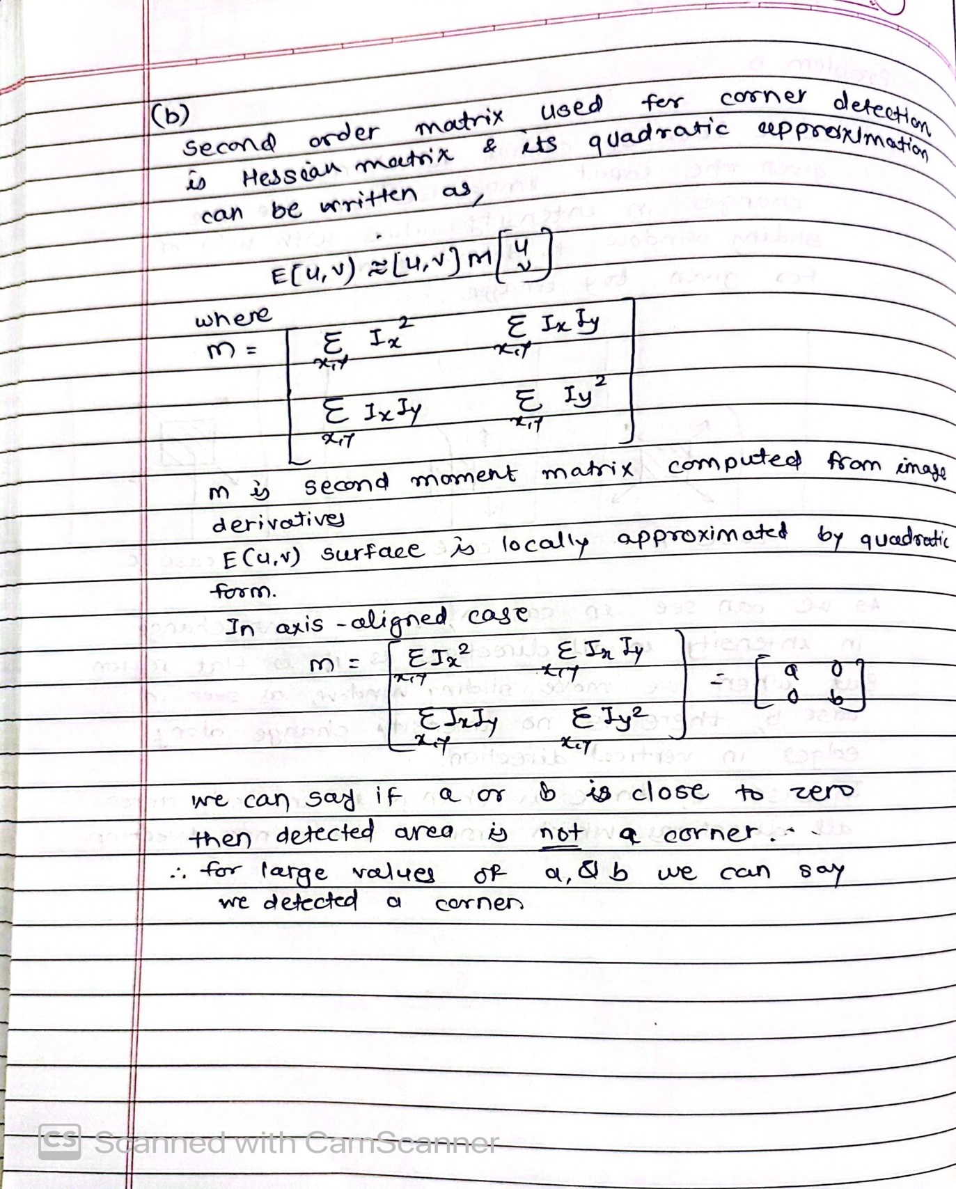

**Problem 6**. (10 points). Write down the steps of Lowe’s SIFT algorithm. Your steps should include the SIFT point detection and the SIFT descriptor generation. Explain why SIFT keypoints are scale invariant to certain degree, and why SIFT descriptor is robust

w.r.t. scale changes, illumination changes, orientation changes and viewpoint changes up to certain degree.

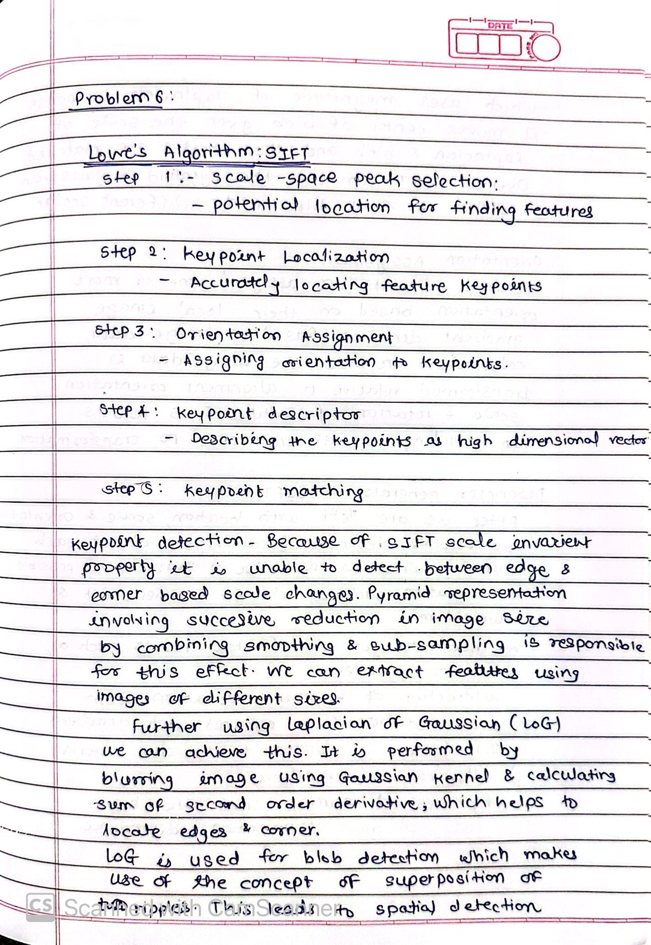

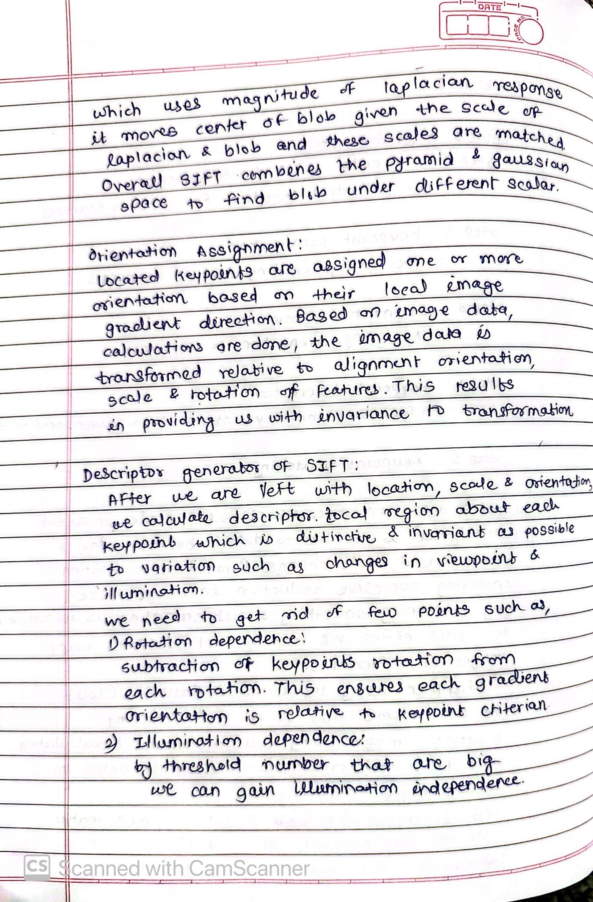



P**roblem 7**. (20 points). Draw the workflows for the following three tasks.

1. Instance-based (object or image patch) matching or recognition.

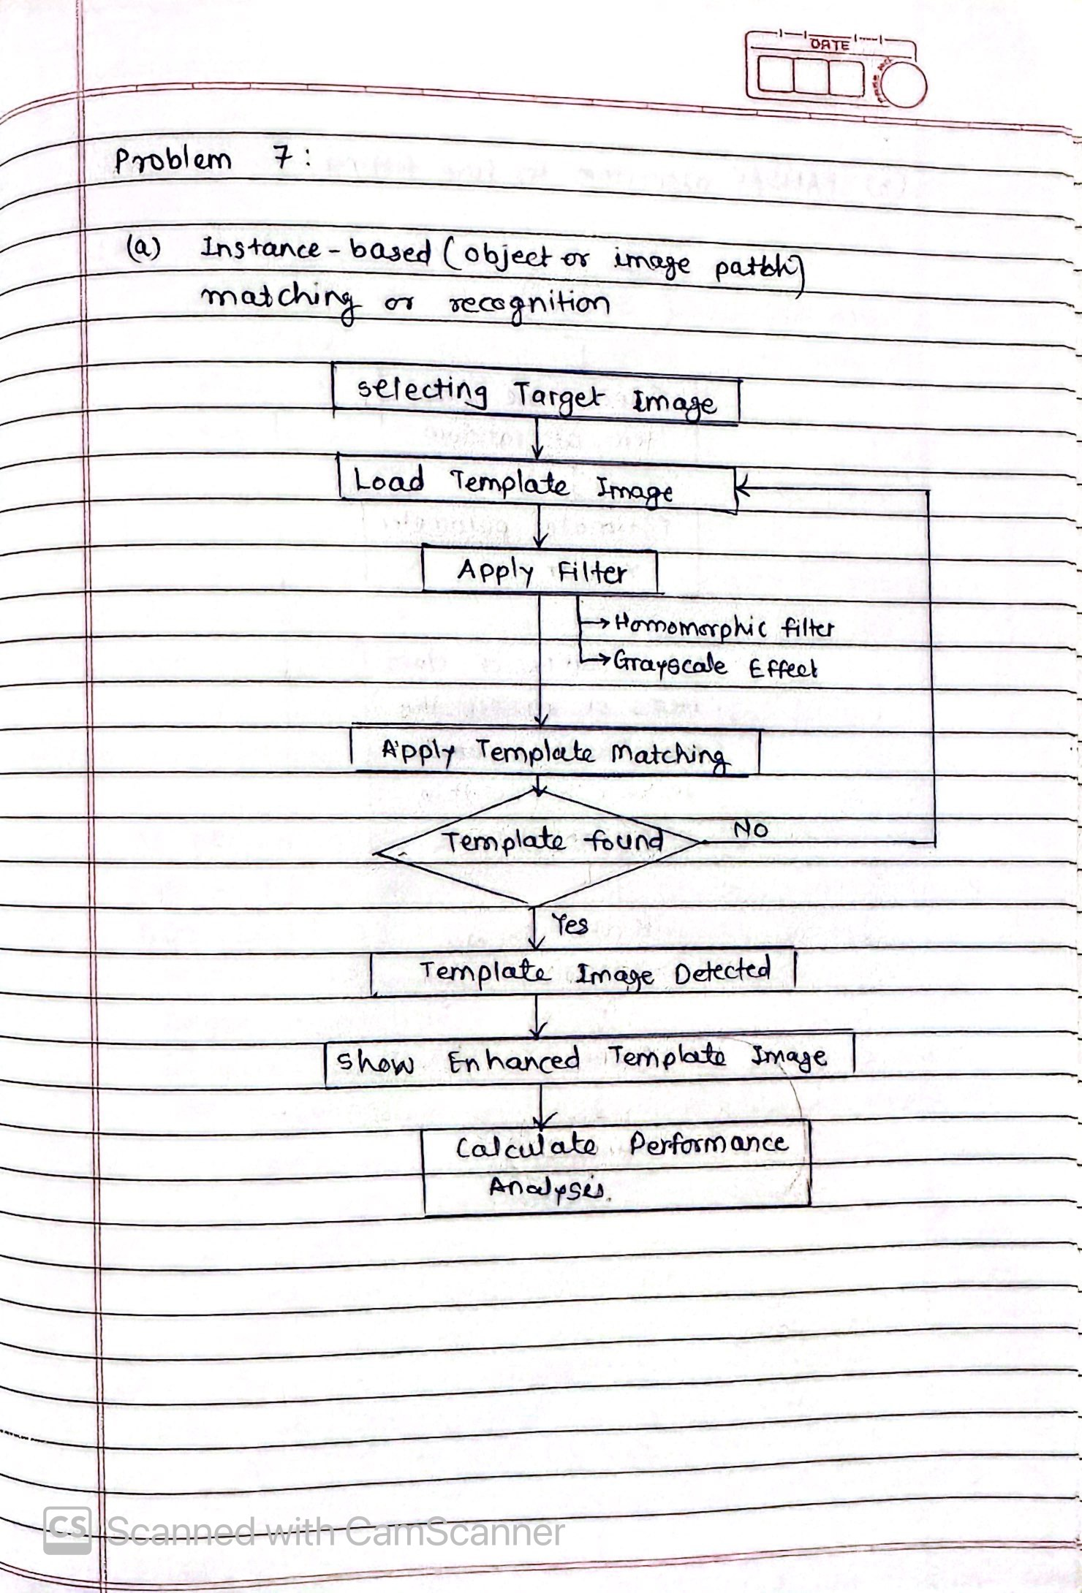

1. RANSAC algorithm for line fitting.

